|  |
| --- |
| Close-up image showing the leaf-sides of two oversized books side-by-side on a bookshelf, with additional books in soft focus background |
| Installation Guide  **Brightcove Extension Module for Magento 2** |
| |  |  | | --- | --- | |  |  | |

Contents

Overview 3

Component Overview 3

Functional Overview 3

Compatibility 3

LimitationS / Constraints 4

Steps for Installation 4

Extraction & Move to right path 4

Enabling the Extension 5

Configure Brightcove Module Credentials 6

Disable the Extension 8

# Overview

This document provides technical instructions for installing Brightcove custom Module, as well as setting up Magento 2.x, for integrating Brightcove Cloud video and media files with Magento 2.x.

# Component Overview

## Functional Overview

This custom Module is developed based on specifications provided by Brightcove. It enables Magento admin users, to upload videos files to the Brightcove Cloud server through SFCC Business Manager, and publish these files on the product details page

## Compatibility

The custom Module is designed for Magento 2.x API with controllers for extended functionality. Clients should install version matching with their Magento architecture.

## LimitationS / Constraints

As mentioned above, Brightcove Custom Module designed to meet Brightcove’s specific requirements to integrate video files residing on Brightcove cloud server with Magento. To make use of this custom plugin, one must contact Brightcove and signup for these services.

# Steps for Installation

## Extraction & Move to right path

* 1. Download the archive file.
* 2. Unzip the file
* 3. Create a folder [Magento_Root]/app/code/Brightcove/Upload
* 4. Drop/move the unzipped files

Note: Download the archive files and paste into working copy folder under app/code/Brightcove/ folder. After pasting the below code we need to enable the module using the following CLI commands.

## Enabling the Extension

* php bin/magento module:enable Brigtcove_Upload
* php bin/magento setup:upgrade
* php bin/magento cache:clean
* php bin/magento setup:static-content:deploy
* php bin/magento cache:flush

## Configure Brightcove Module Credentials

After Successful install of Brightcove custom module. Follow below steps to reach given screen (Brightcove menu)

Store => Configuration => Brightcove (left tab) => Brightcove Video Configuration

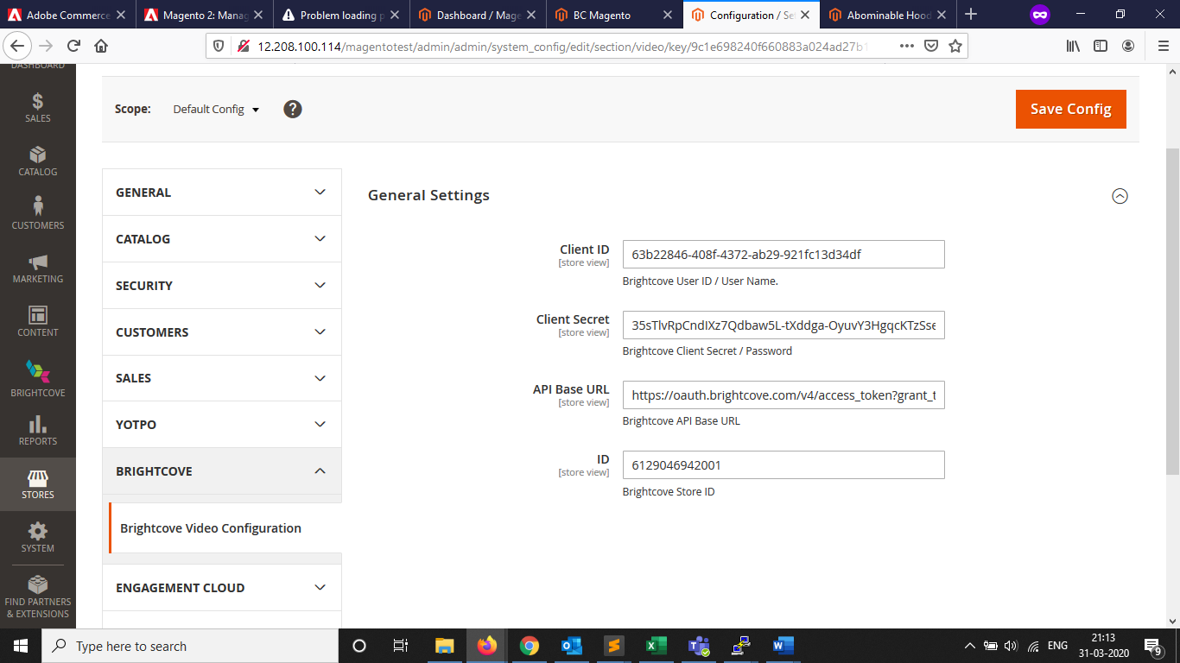

General Settings to be configured. Follow below help;

Client ID : REST Client / User ID

Client Secret : REST Client Secret / password.

API Base URL : “https://oauth.brightcove.com/v4/access_token?grant_type=client_credentials”

ID : Brightcove Store ID

After providing details to the fields;

Click on “Save Config”

Brightcove Extension is now ready to use.

## Disable the Extension

Run below commands to disable Brightcove extension

* php bin/magento module:disable Brightcove_Upload
* php bin/magento setup:upgrade
* php bin/magento cache:clean
* php bin/magento setup:static-content:deploy
* php bin/magento cache:flush